Searching the Website

* Search-bar page:
  + Type in the desired topic in the search bar.

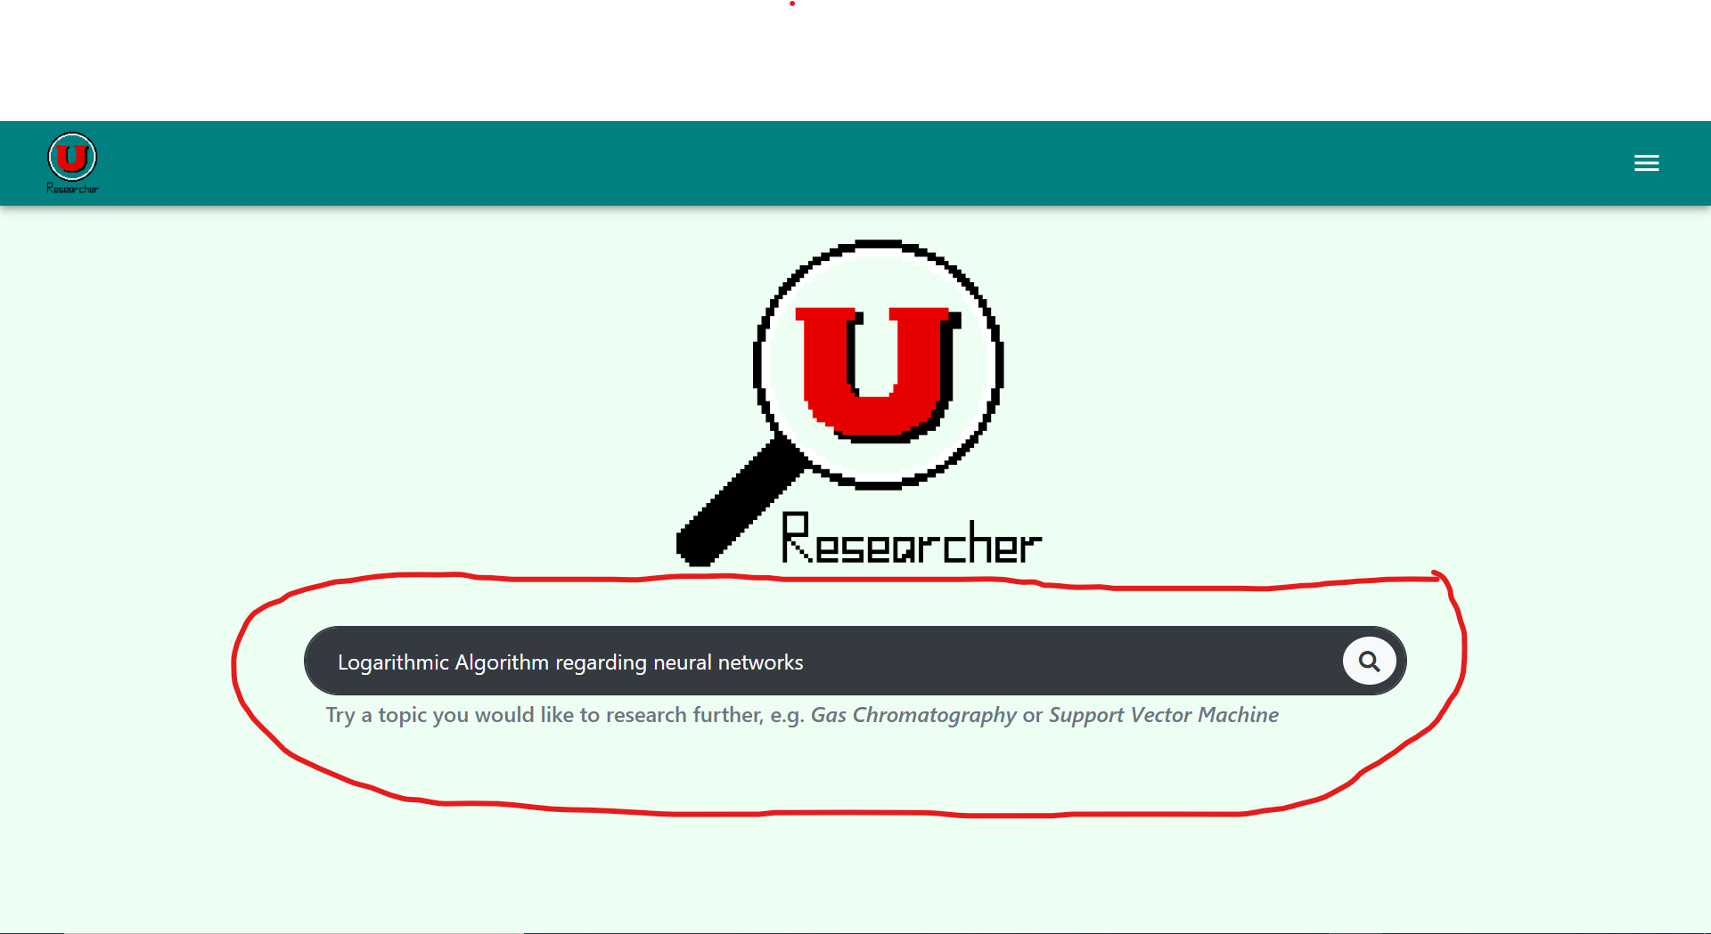

* + Click on the magnifying glass or hit enter to begin the search.
  + Wait for the web page to load the results.

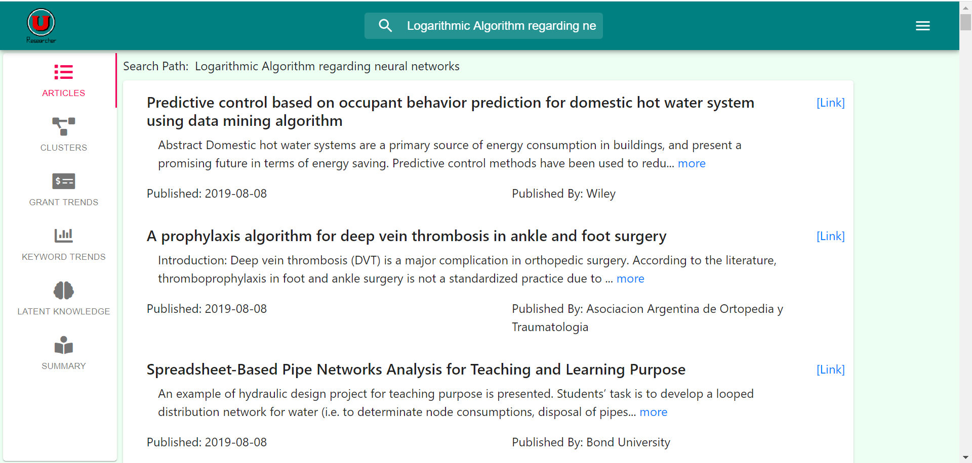

* From results page:
  + Type in the desired topic in the search bar at the top of the page.

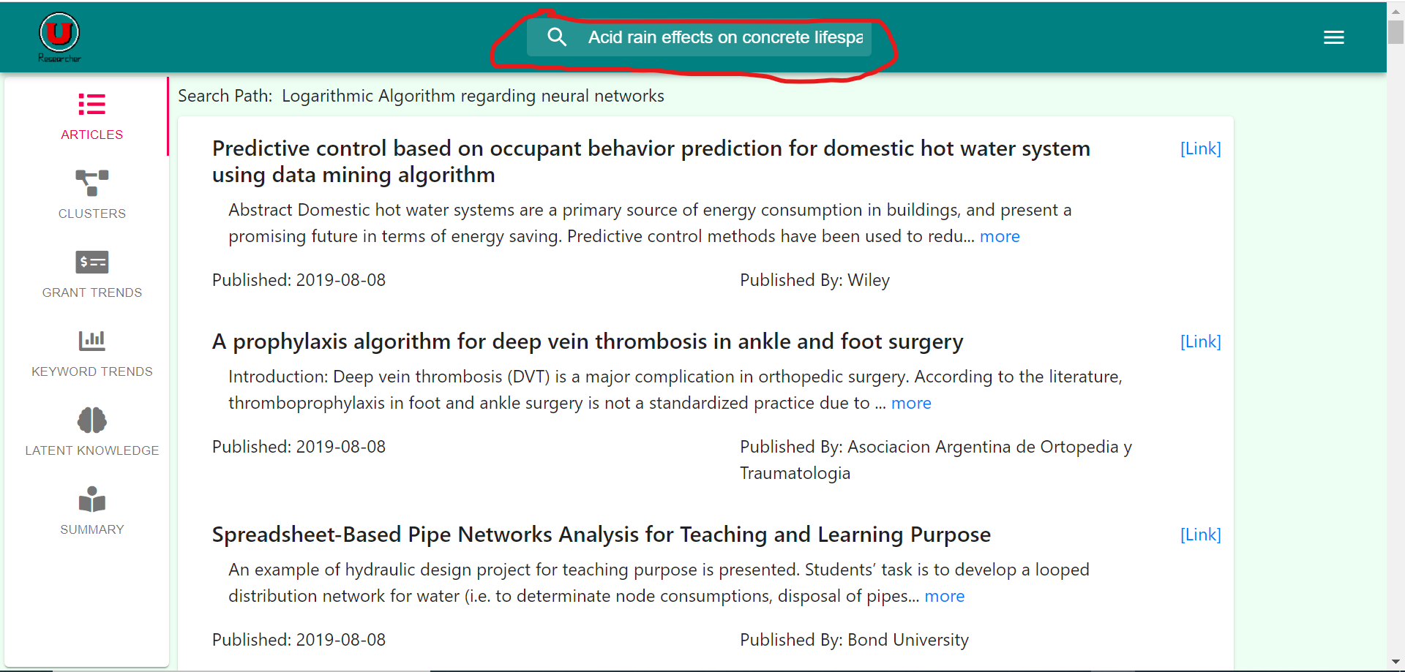

* + Click on the magnifying glass or hit enter to begin the search.
  + Wait for the web page to load the results.

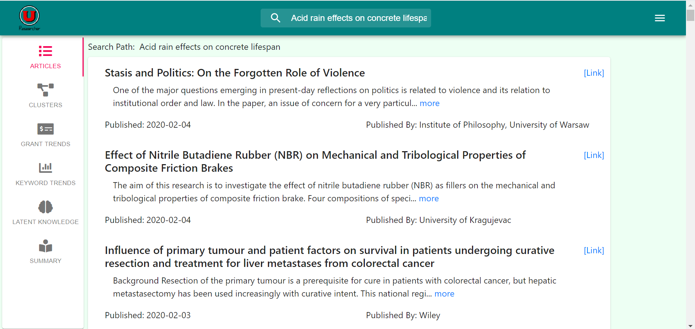

* Restarting a Search:
  + Click on the logo in the upper left-hand corner or refresh the home page.

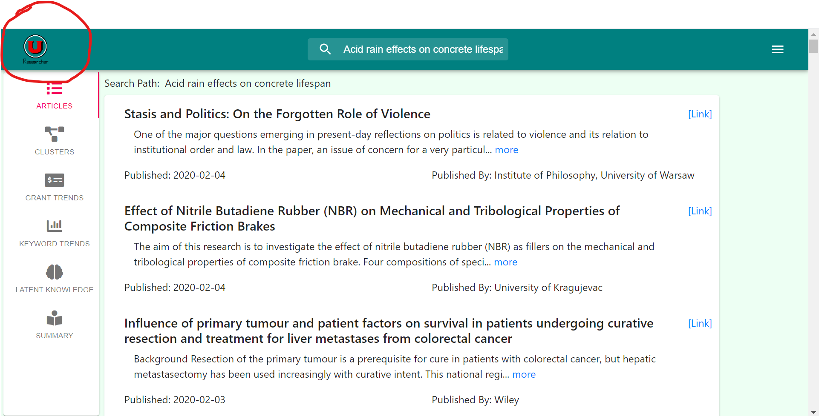

* Following Research Papers:
  + Click on the link next to the desired research article.

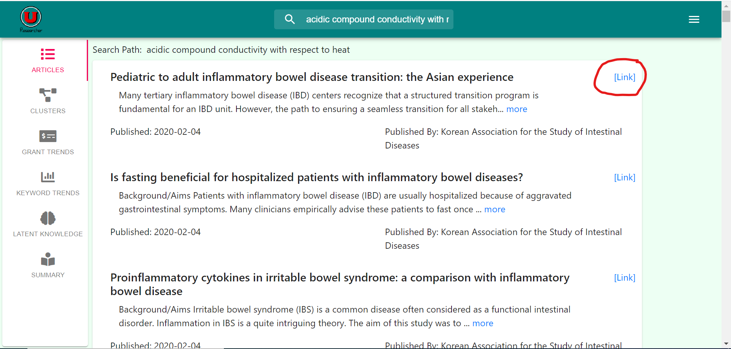

* + Wait for the application to redirect to the web page.



Using the Clusters

* Examining Clusters
  + After a successful search, click on the “Clusters” side panel.

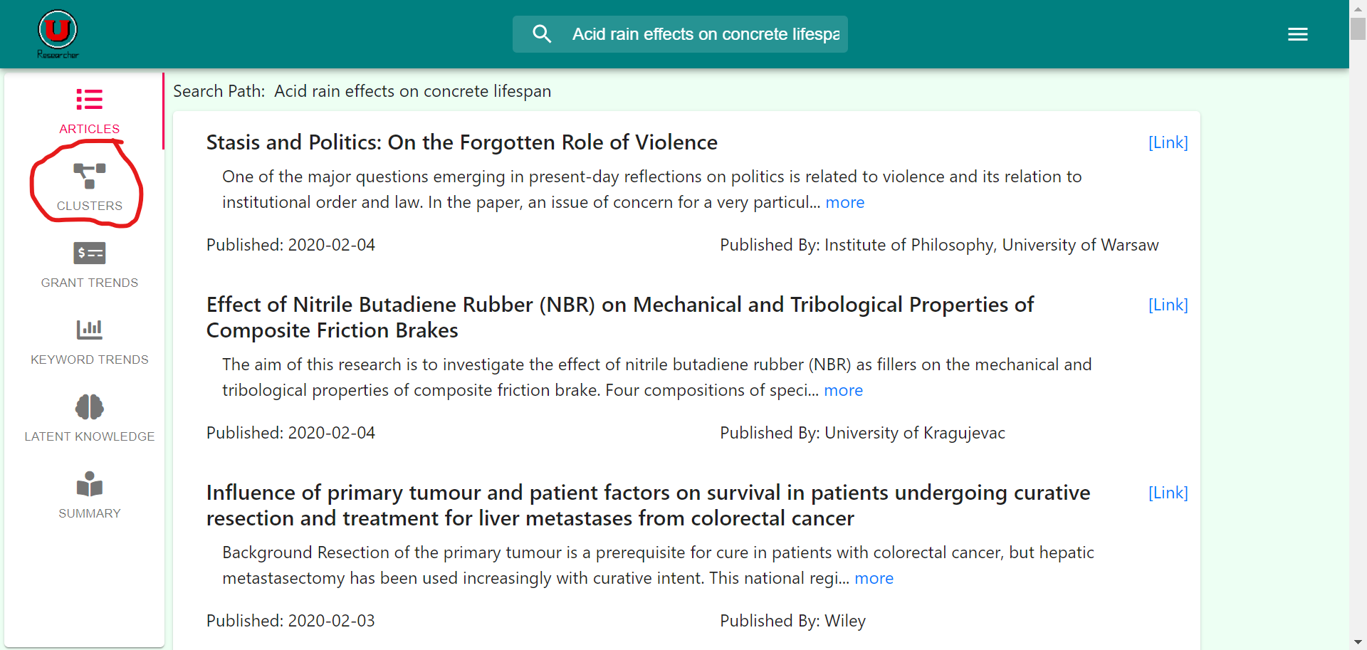

* + Wait for the clusters to load from the search.

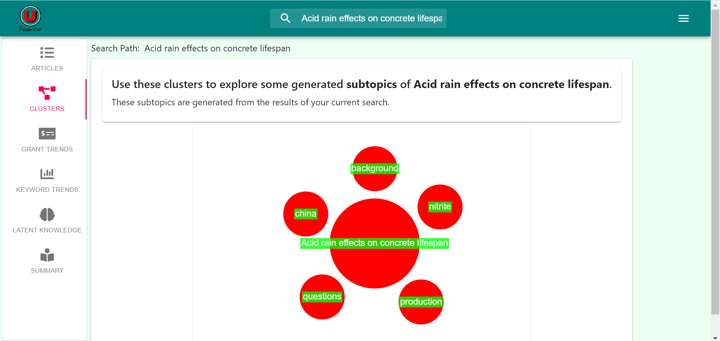

* + Click on a cluster to begin a search with the cluster key word within the established search results.
* Meaning of Cluster.
  + The clusters of this web application represent the commonly categorized topics within the searched field.
  + For example, given the search “acid rain effects on concrete lifespan,” the program determines that all papers within this topic can be categorized into “china,” “background,” “nitrite,” “production,” and “questions.”
  + Clicking on a cluster will create a search within both the original search and the chosen cluster topic.

Using Grant Analysis

* Examine Graphs of Grants
  + Click on the “Grant Trends” side panel.

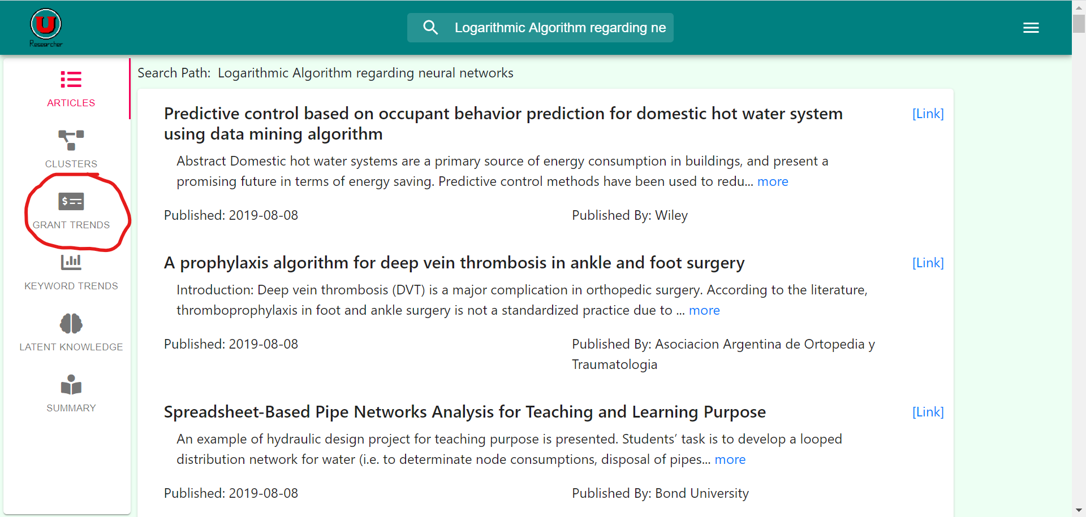

* + Wait for the graphs to load.

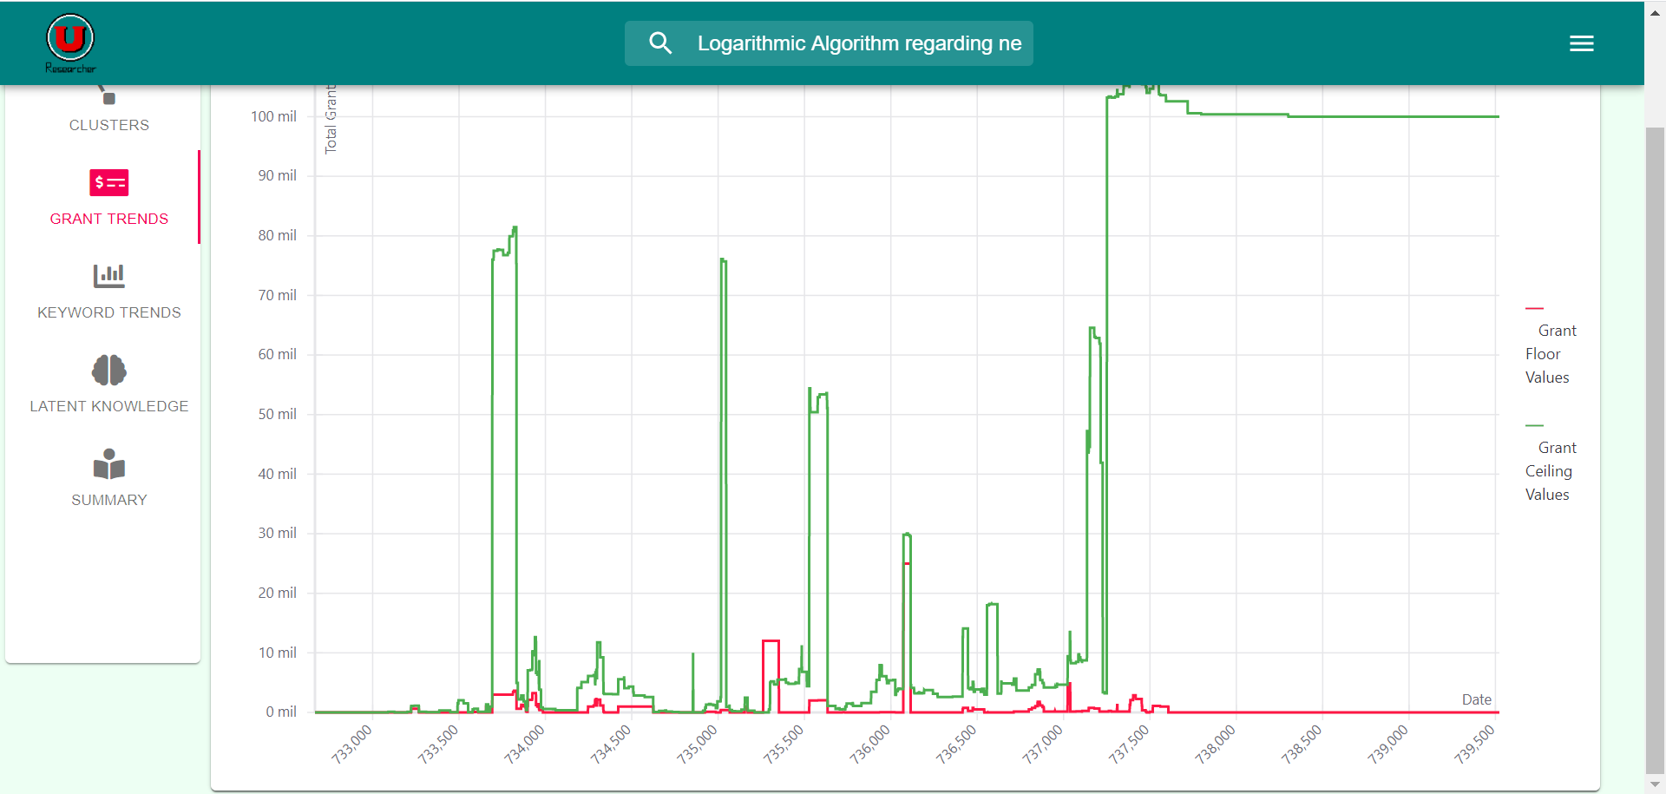

* Interpreting the Graph
  + The graph consists of grant allocations from “grants.gov.”
  + Each data point represents the sum of grant values for either the floor or ceiling at a point in time.
  + The x-axis measures time; while, the y-axis measures the award response in millions of dollars.

Using Keyword Analysis

* Examine Graphs of Grants
  + Click on the “Keyword Trends” side panel from the results page.

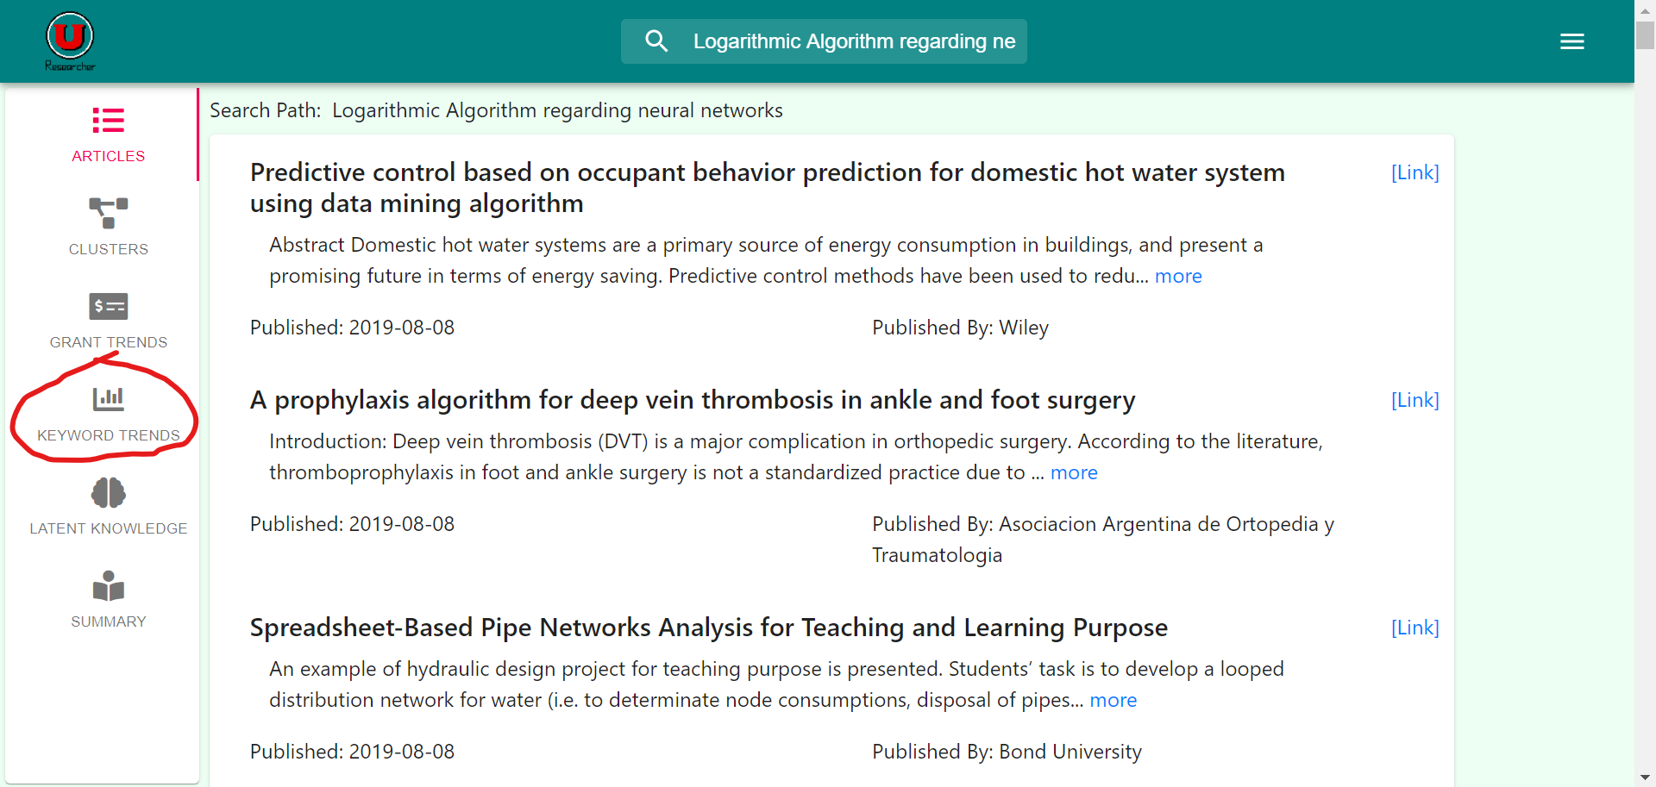

* + Wait for the results to load.

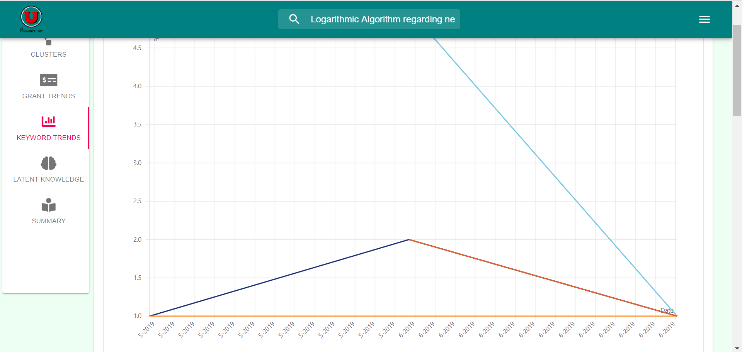

* Choosing Keywords
  + Choose keywords to include/exclude in the graph.

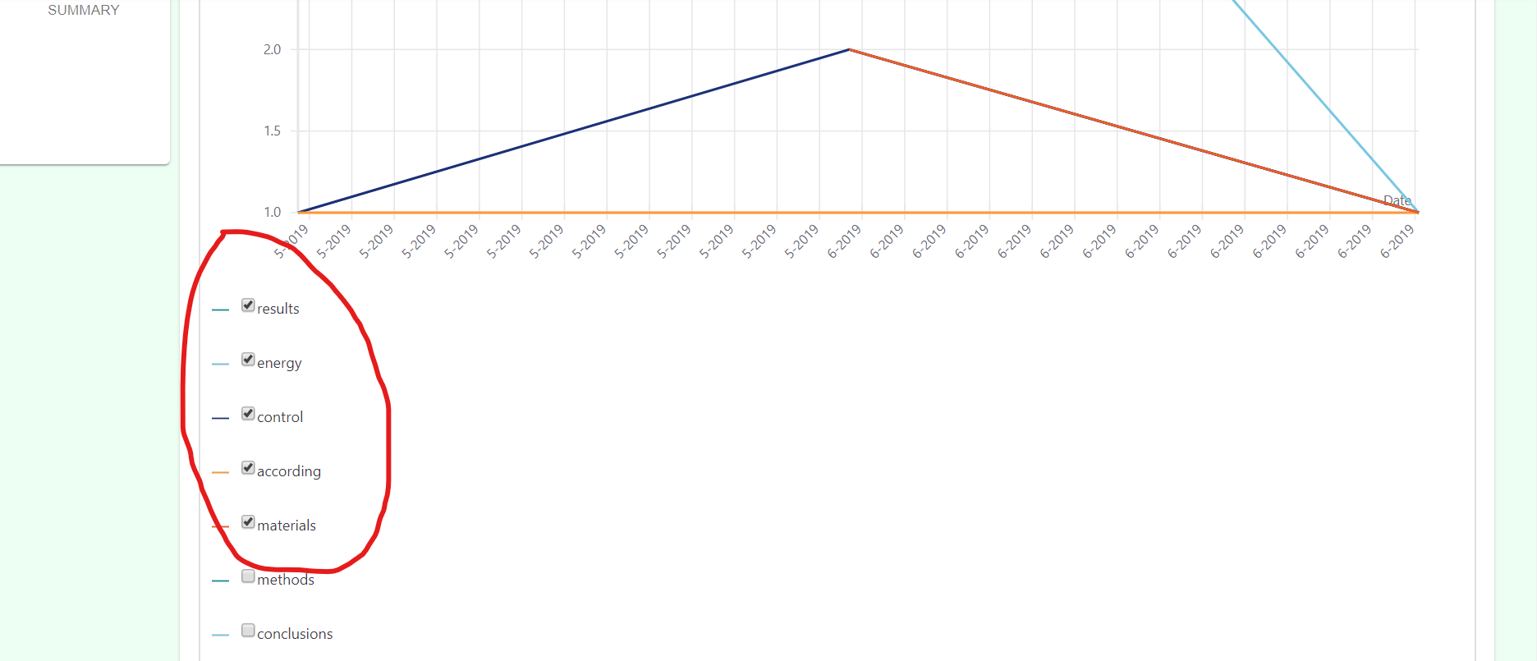

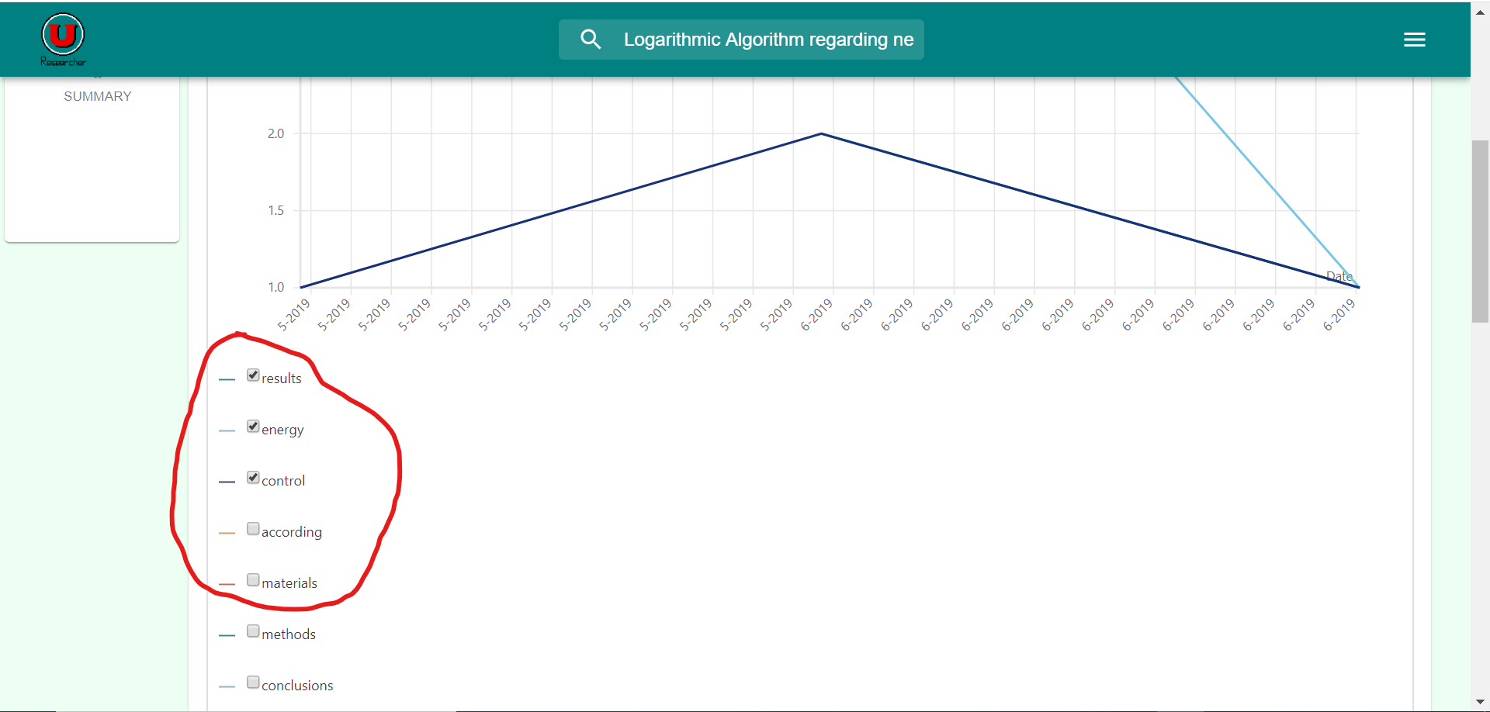

* + Wait for the system to automatically update the graph.

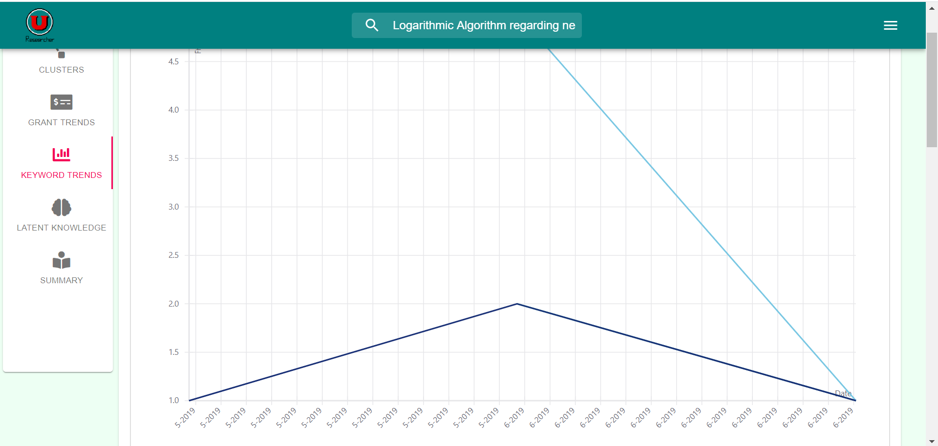

* Interpreting Keyword
  + The graph uses keywords analyzed from the DOAJ to represent the frequency of keywords with respect time.
  + The legend below the graph indicates which line connects to which keyword.
  + The x-axis represents time; while, the y-axis measures the frequency, number of times on average the indicated word appears in a paper.

Using Latent Knowledge Analysis

* Accessing Latent Knowledge Graph
  + Click on the “Latent Knowledge” side panel from the results page.

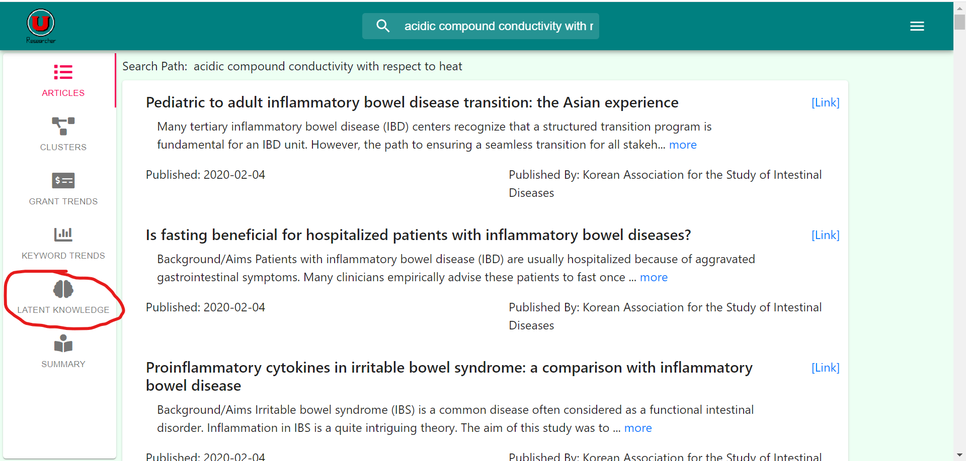

* + Wait for the results to load.

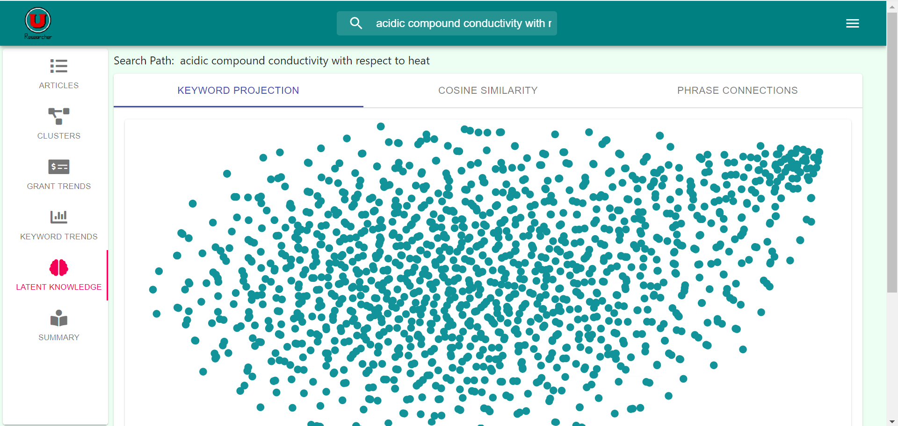

* + Access the graph from the Latent Knowledge page at any time by clicking the keyword projection tab.

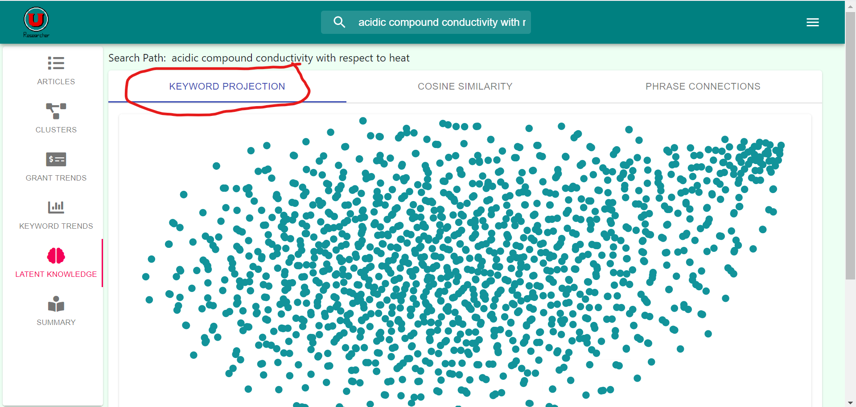

* Isolating Specific Data Points
  + Click on the “Target Word(s)” bar to show a list of available words selection.

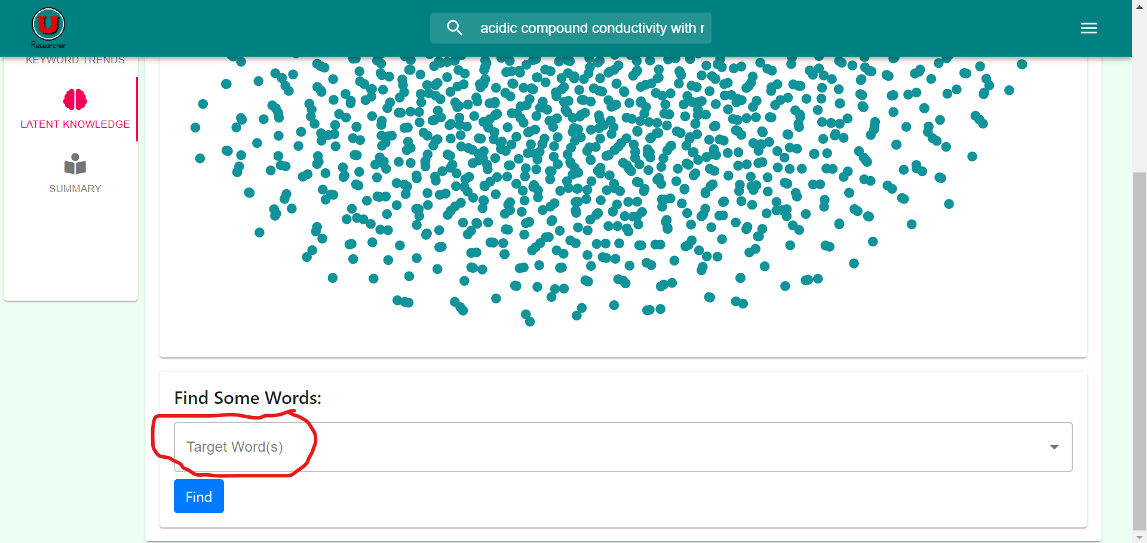

* + Select any desired words to isolate.
  + Clink the “Find” button to select and isolate the words on the graph.

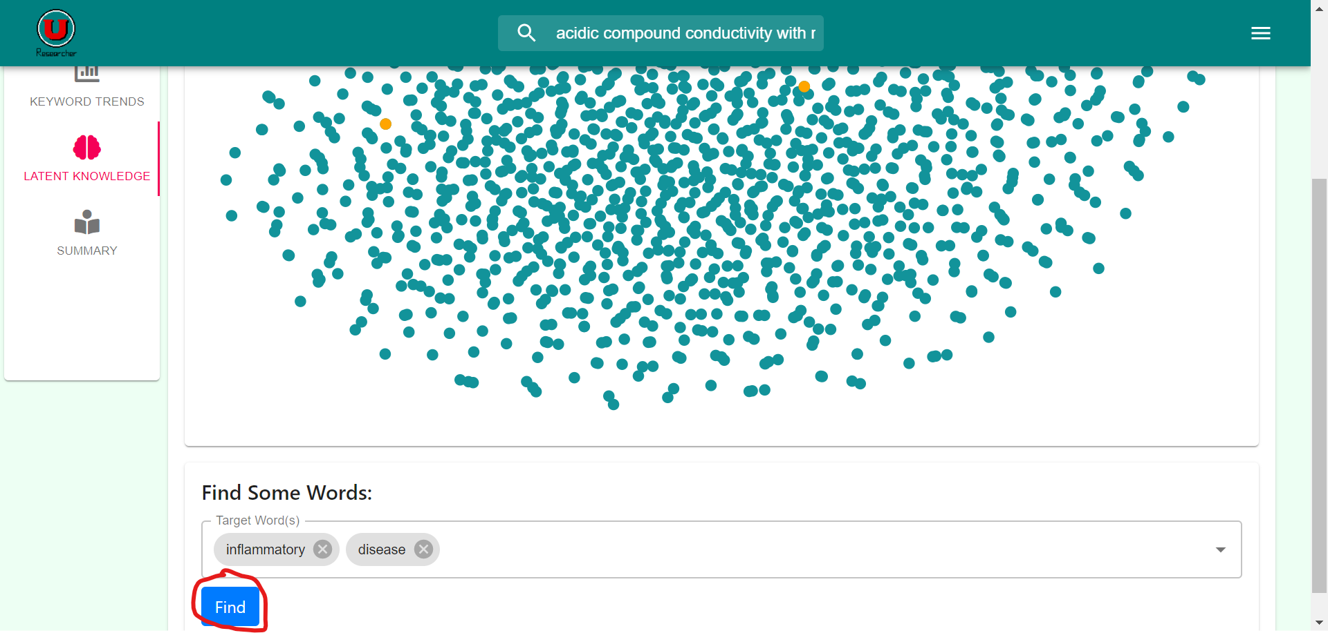

* Interpreting Keyword Projection
  + The graph uses words from the articles in the search results.
  + Each point represents a word interest in the search topic.
  + The closer the words are located on the graph, the more likely the words are related or share a close proximity in the given articles.
* Accessing Cosine Similarity
  + Click on the “Cosine Similarity” tab on the Latent Knowledge results page.

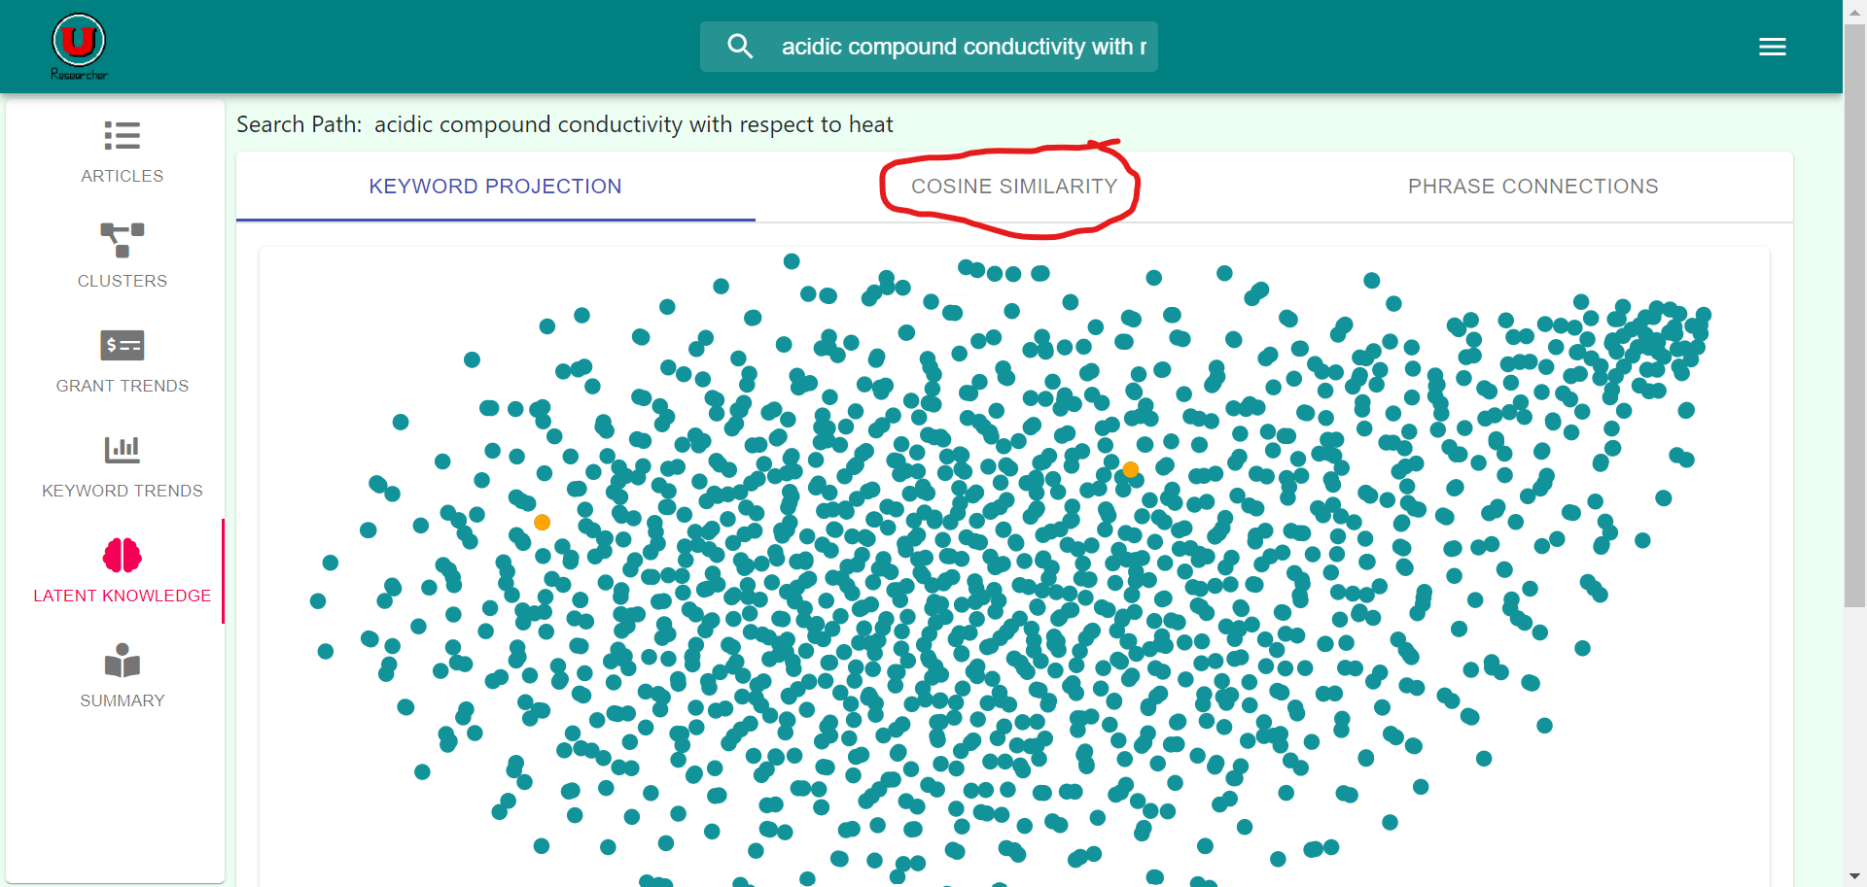

* + Wait for the results to load.

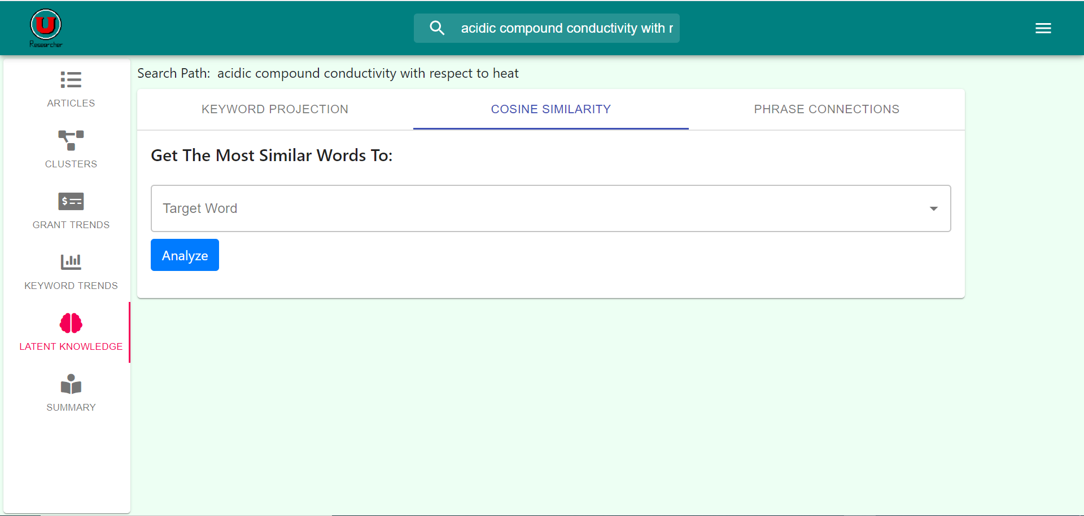

* Using Cosine Similarity
  + From the “Cosine Similarity” tab, click on the “Target Word” to show a list of words to analyze.

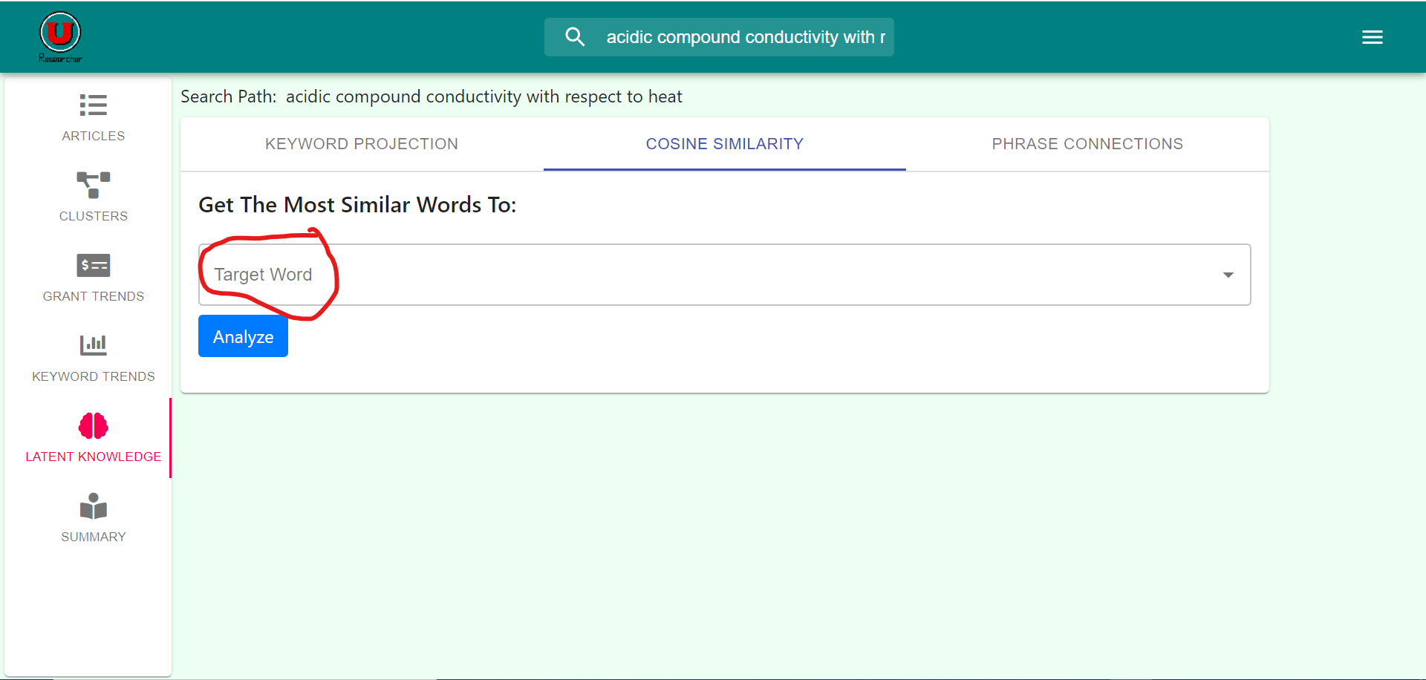

* + Select a word to a analyze and hit the Analyze button.
  + Wait for the results to load.

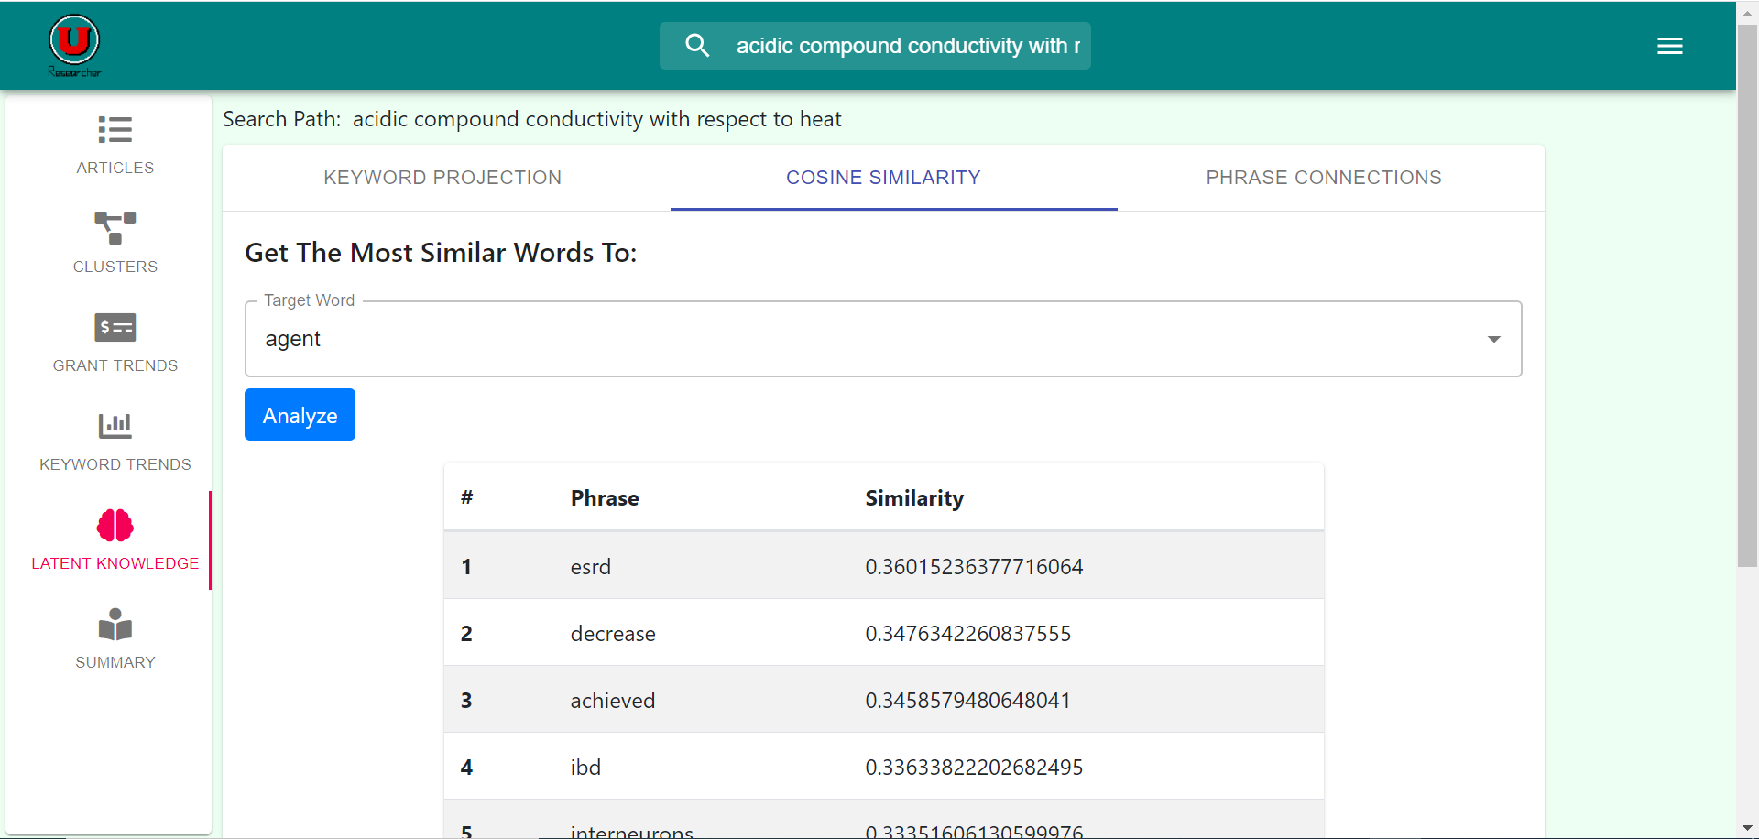

* Interpreting Cosine Similarity
  + The list consists of phrases and words found within the article search space.
  + The list shows the rating of connections of words to the target word under “similarity.”
  + If a word located higher on the list than another word, it has a greater similarity than that word.
* Accessing Phrase Connections
  + Click on the “Phrase Connection” tab on the Latent Knowledge results page.

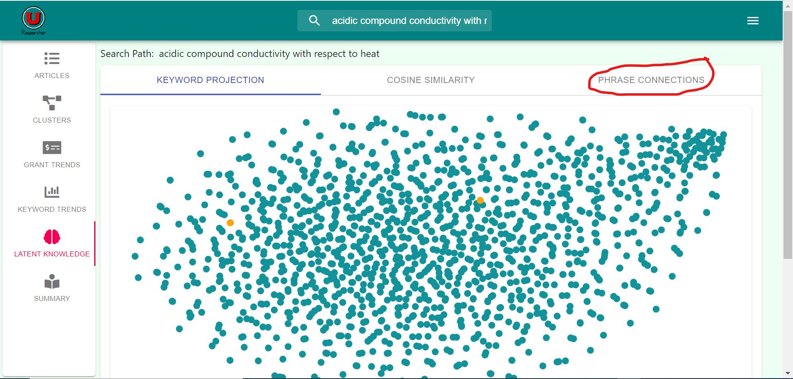

* + Wait for the results to load.

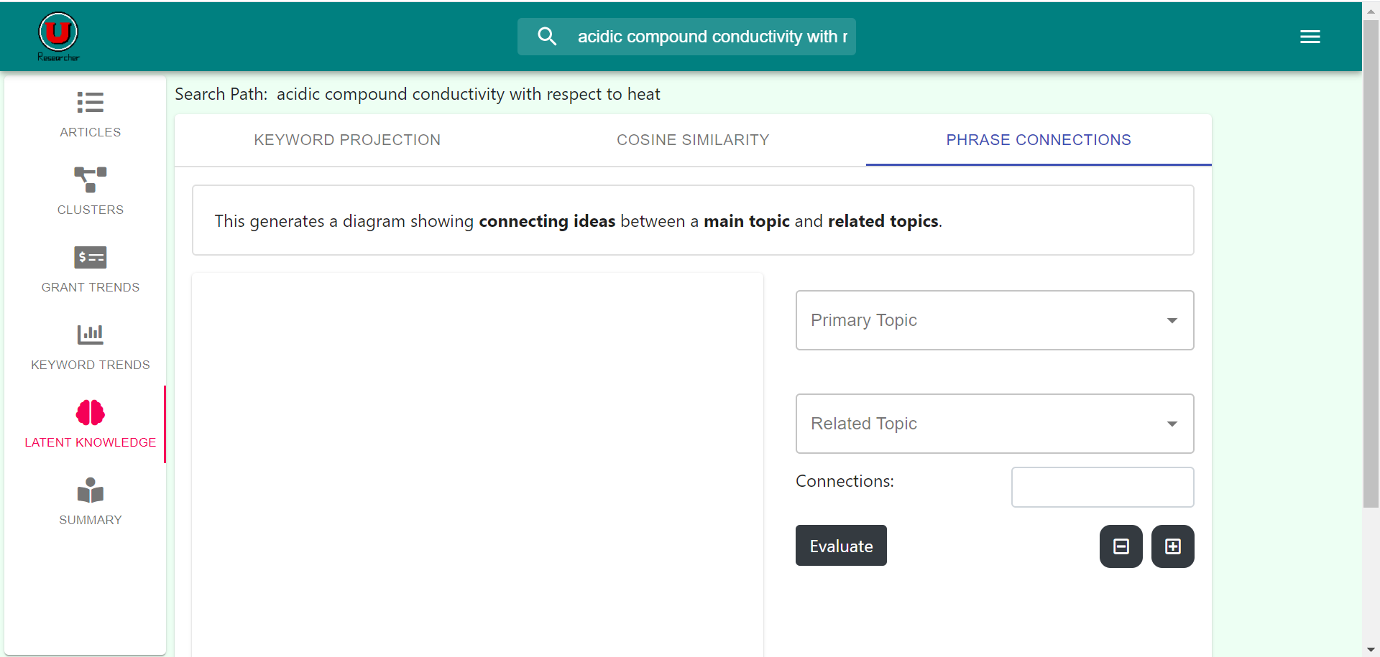

* Using Phrase Connections
  + Select a primary topic and related topic to compare.

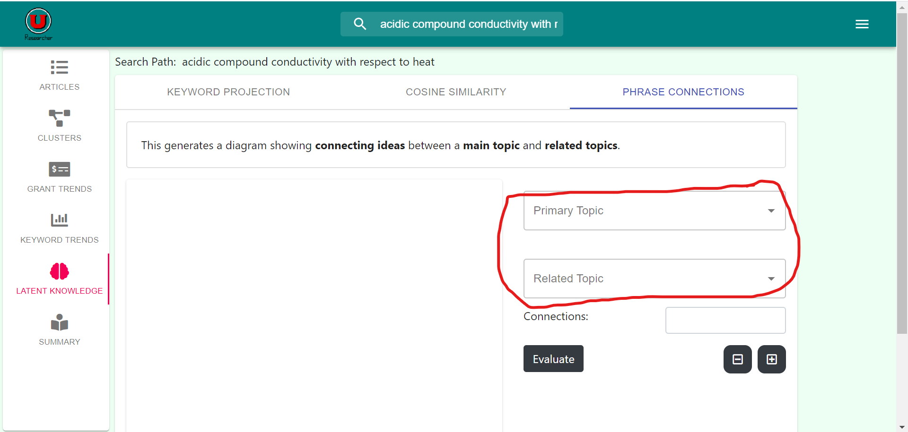

* + Choose the number of connections you wish to see between topics.

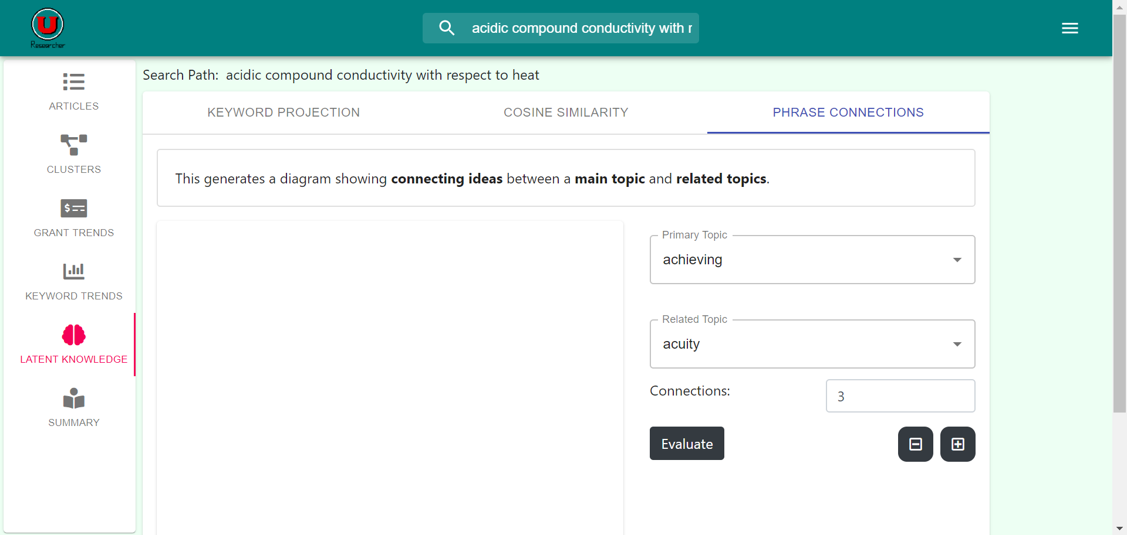

* + Click on “Evaluate” and wait for the result to load.

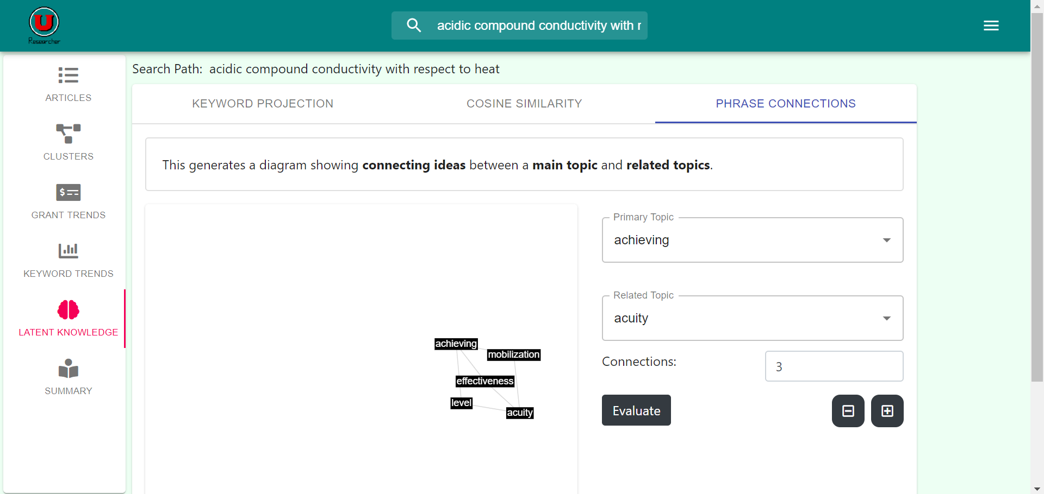

* Interpreting Phrase Connections
  + The nodes on the graph originate from the pool of keywords from the articles from search results.
  + Each node between the primary topic and related topic represents a connection between the topics.
  + Connections will generate that number of most common link words.

Summaries

* Accessing Summaries
  + From the results page, click on the “Summary” side panel.

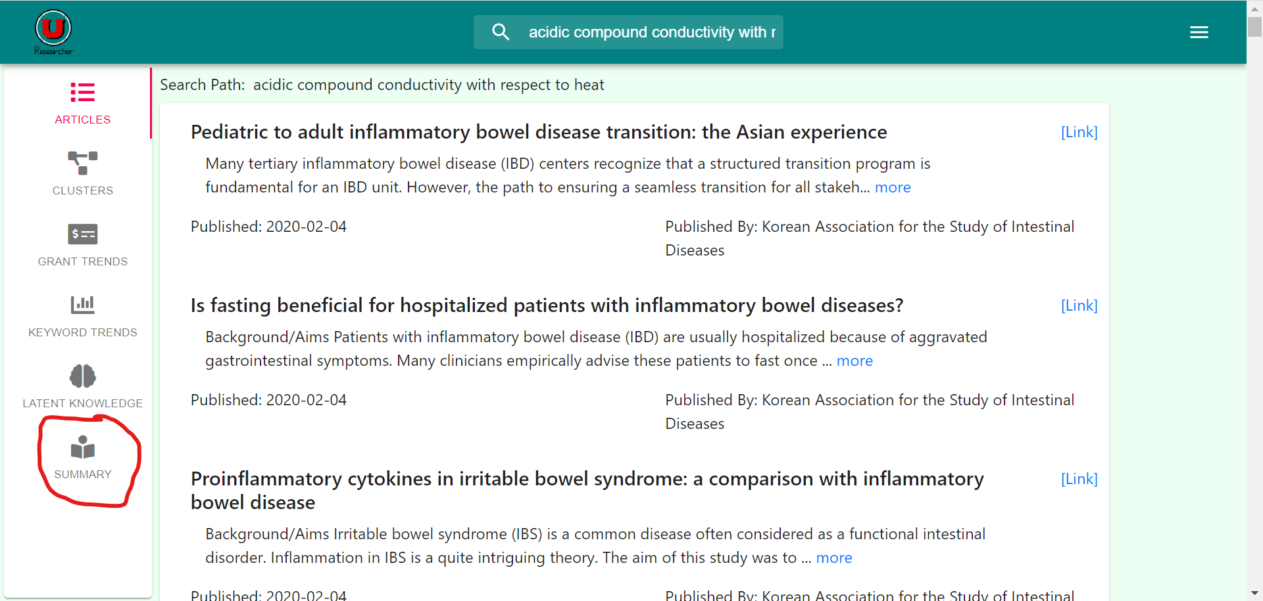

* + Wait for the result to load.

